**1.1 Voltage divider**

**!.1.1 What is the DC value at the load?**

Ans: 3.000 V

**1.1.2 Attach the graph response of the DC sweep.**

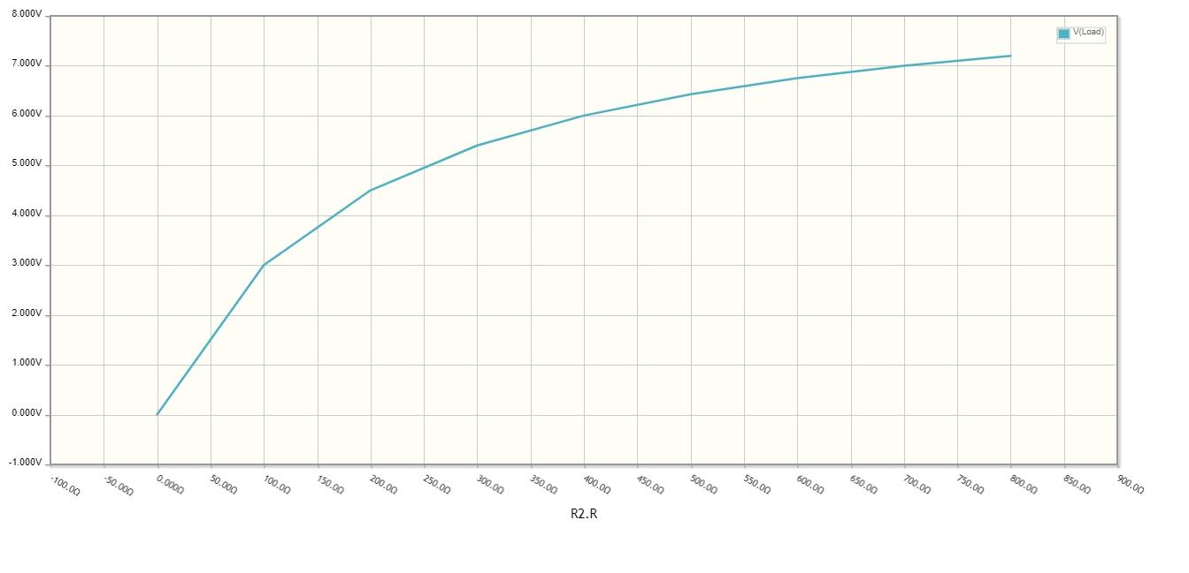

**1.2 Buck converter**

**1.2.1 What percentage of the time will the PMOS allow current to flow through?**

Since the clock cycle is 33%, the current through PMOS will flow 67% of the time.

**1.2.2 Screenshot the voltage over time graph of Vin, Vswitch and Vout.**

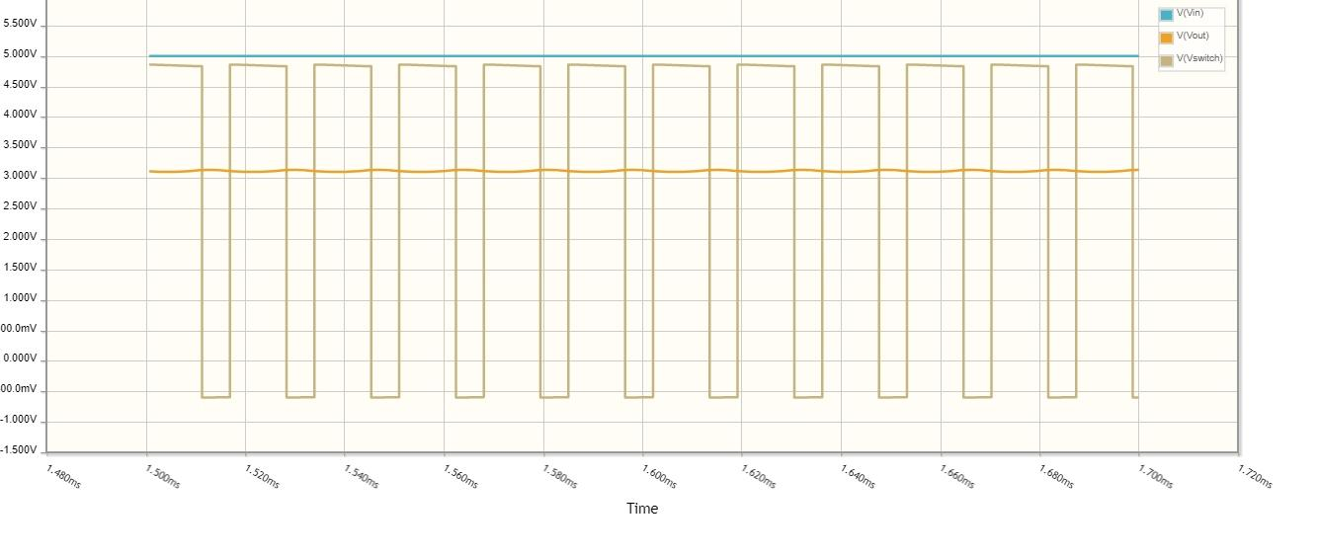

**1.2.3 Screenshot the current over time graph at Vin, the left side of the inductor, and the**

**top of the diode.**

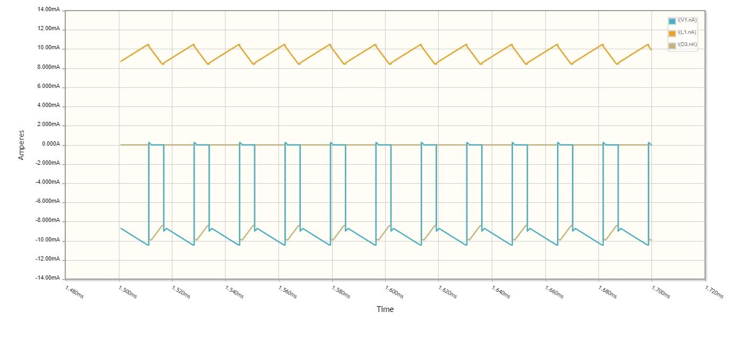

**1.2.4 What is the relationship between the current at Vin, the current entering the diode,**

**and the current entering the inductor? Is this expected, and why?**

The relationship can easily be explained by dividing the discussion into two parts:

1. **When the MOSFET is on**

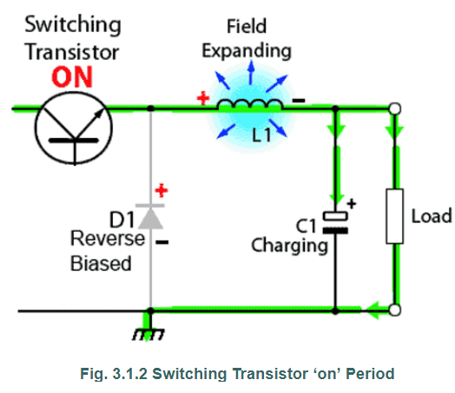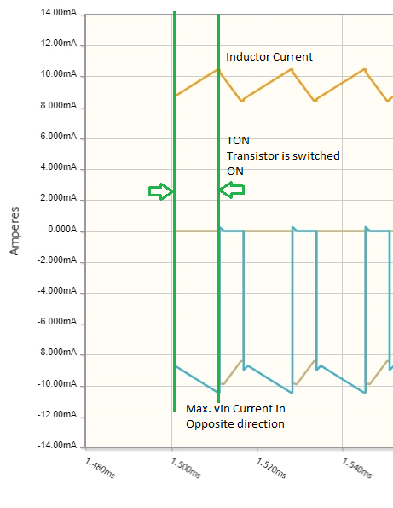

(Image taken from : Green lines indicate the time period when MOSFET is on

<http://www.learnabout-electronics.org/PSU/psu31.php>)

**Since the duty cycle is 33%, the MOSFET is on for 67% of time and off for 33% of time.It indicates the On-time of MOSFET is approximately double its Off-time, which is visible in the graph.**

The MOSFET is on during the time duration as indicated by green lines in the graph.

**Diode’s current**: When the MOSFET is on, the diode is in reverse biased mode due to which no current flows through it. That’s why, the brown line on graph (Diode current) is shown as zero between the green lines.

**Inductor’s current**: Since the diode is inactive, the transistor and the inductor are in series and current flows through the inductor generating an emf. Therefore current through increases throughout the “On-cycle” of MOSFET, as shown by yellow line in the graph between the green lines.

**Current at Vin:** Since the current through the inductor comes from Vin, as the current through inductor increases, the current at Vin increases with exactly the same amount as inductor’s but in the negative direction (Opposite), as indicated by brown line in the graph between the green lines.

**Relationship**: The current through inductor increases from approx. 9 to 10.2 mA and current at Vin decreases from approx. 10.2 to 9 in the negative direction.

1. **When the MOSFET is off**

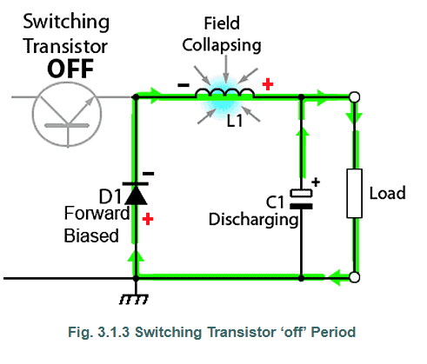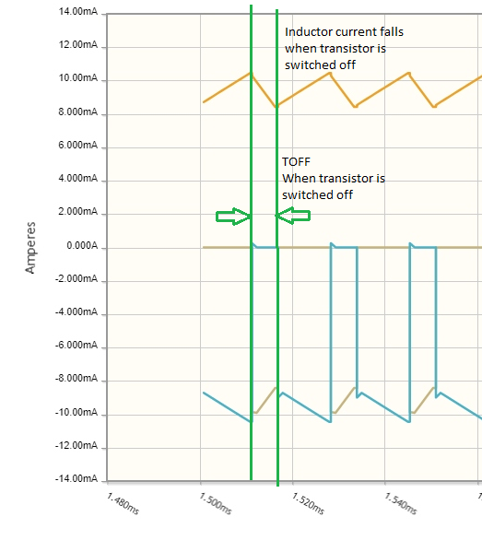

(Image taken from: Green lines indicate the time period when MOSFET is off

<http://www.learnabout-electronics.org/PSU/psu31.php>)

The MOSFET is off during the time duration as indicated by green lines in the graph.

The MOSFET is off for 33% of time.

**Current at Vin:** Since the MOSFET is off, the path of power source cuts off and therefore there is no current at Vin, as indicated by blue line between green lines in the graph.

**Current through diode:** The only power source left in the circuit now is the back emf from the inductor, due to which diode enters into forward-biased mode and current through diode increases as shown by brown line between green lines in the graph.

**Current through inductor:** Since, the back emf of inductor is being used to drive the load, current through inductor decreases in proportion to the current increasing through the diode, as indicated by yellow line between green lines in the graph.

**1.3 Boost Converter**

**1.3.1 Screenshot the voltage over time graph of Vin, Vswitch and Vout.**

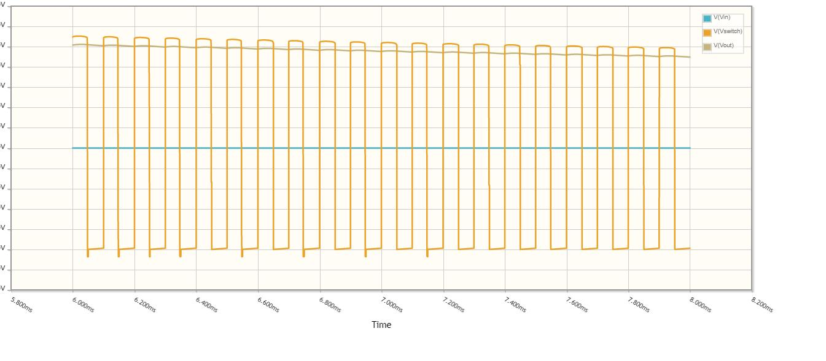

**1.3.2 Screenshot the current over time graph at Vin, the left side of the diode, and the top of the**

**Transistor.**

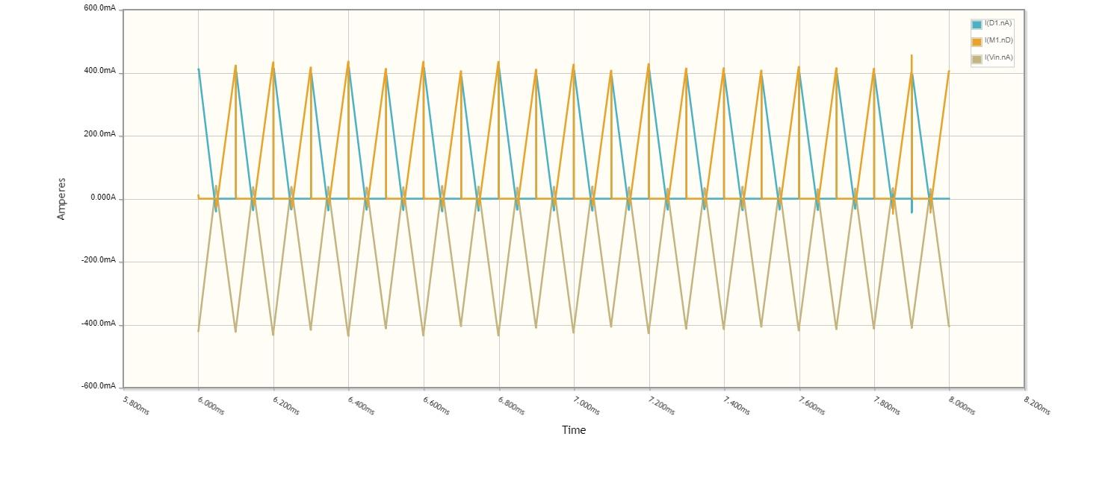

**1.3.3 What is the relationship between the current at Vin, the current entering the diode, and the current**

**entering the transistor? Is this expected, and why?**

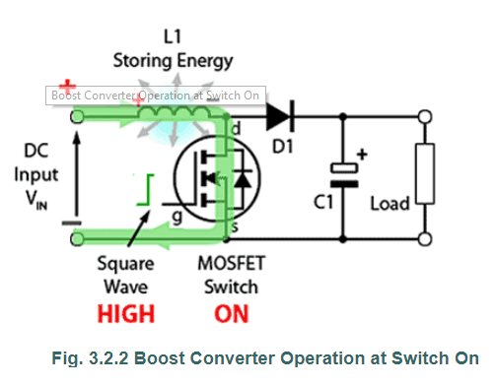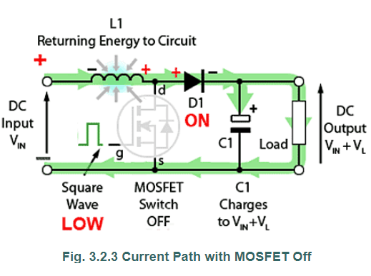

(Images taken from : <http://www.learnabout-electronics.org/PSU/psu31.php>)

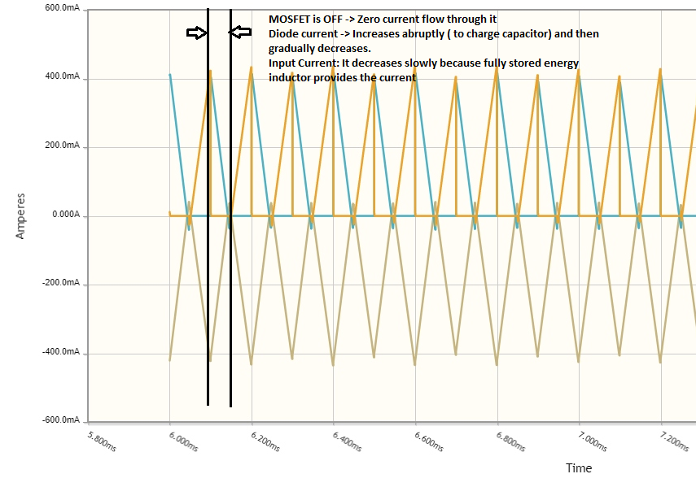

The relationship can easily be explained by dividing the discussion into following parts:

1. **When the MOSFET is switched on for the first time, and then switched off**

**Since the duty cycle is 50%, the MOSFET is on for 50% of time and off for remaining 50% of time.It indicates the On-time of MOSFET is exactly equal to its Off-time, which is visible in the graph.**

When the MOSFET is on, a path of current is formed between inductor, MOSFET and the power supply.Due to inductor and power supply being in series with each other, current starts to flow through it and an emf is generated across it. Since this path is the least resistant path, this is the only which is active, the rest of the circuit is inactive as no current flows through it.

**Current through MOSFET:** When the MOSFET is switched off, the path involving the MOSFET is open and no current flows through it, as indicated by yellow line between black lines in the graph.

**Current through diode:** When the MOSFET is switched off, the current through diode abruptly increases to charge the capacitor and then gradually decreases, as indicated by blue line between the black lines in the graph.

**Current at Vin:** When the MOSFET is switched off, the current at Vin decreases gradually as the current required is now provided by the back emf of the inductor, and this decrease(from 400mA to 0mA) is in proportion with the decrease in the diode’s current(from 400mA to 0mA) but in the negative direction (Opposite), as indicated by brown line between the black lines in the graph.

1. **When the MOSFET is switched on again**

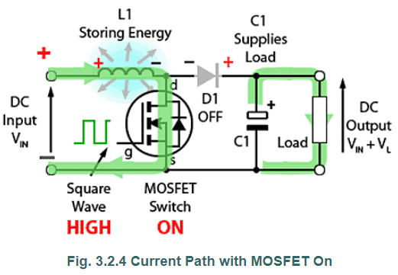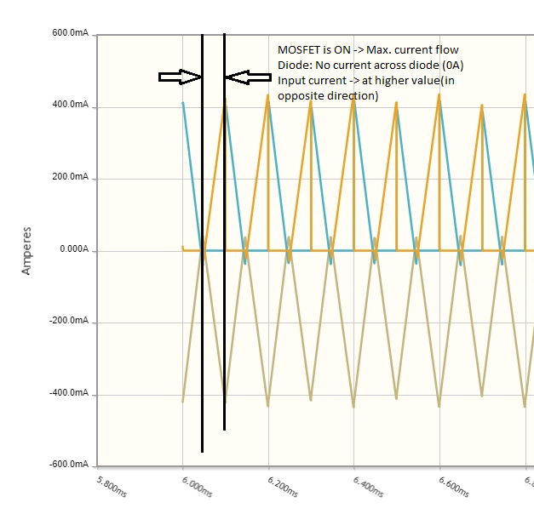

**Current through diode:** When the MOSFET is switched on again, the diode is in reverse-biased mode, and therefore no current flows through it, as indicated by blue line between black lines in the graph.

**Current through MOSFET:** When theMOSFET is switched on again, the current starts to flow through it and increases to reach the maximum value of 400mA.

**Current at Vin:** The current at Vin increases from 0mA to 400mA to store the energy at the inductor again, and that same current flows through the MOSFET as they are in series. Therefore, the current at Vin and the current through MOSFET both increase from 0 to 400mA but the current at Vin is in negative direction(Opposite) to that through MOSFET.